  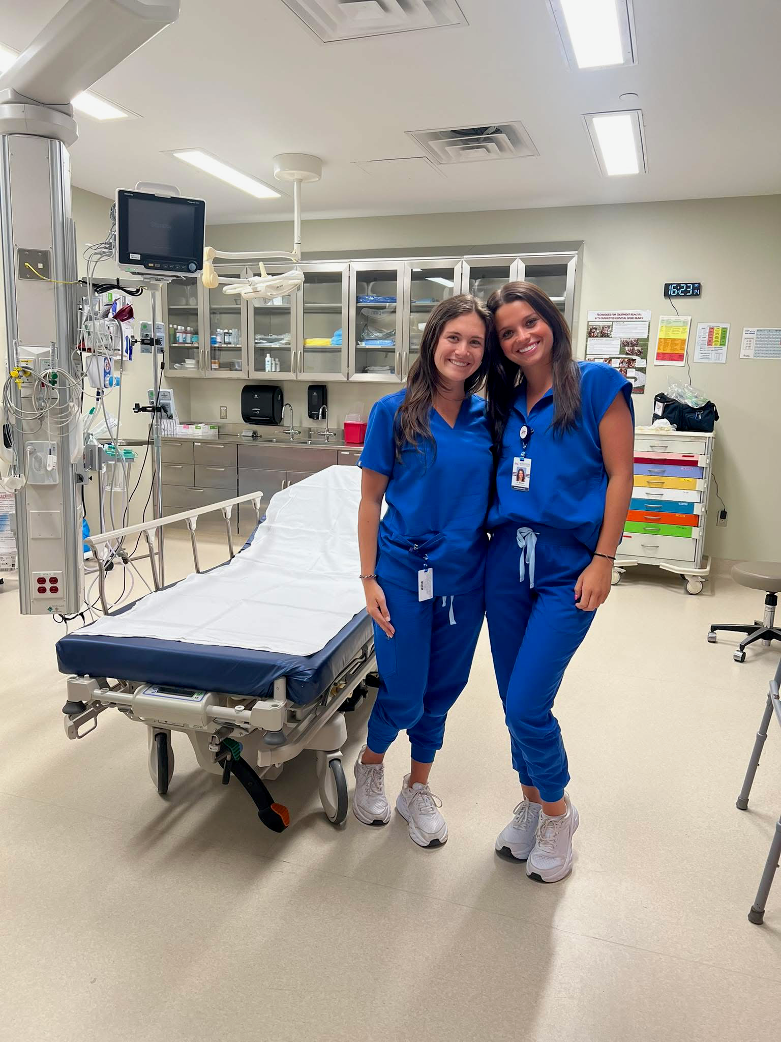
    - 2026 Student nurse externship
    - May 26 – July 31
  The Student Nurse Externship program at Winston Medical Center is a summer program that allows the student to work with registered nurses with years of clinical experience in the areas of critical care and emergency nursing. The students will work alongside these registered nurses, learn from a rural emergency department environment, and practice the approved skills. The objectives for our clinical experience are for the student to gain knowledge in patient care, communication skills, critical thinking and reasoning, and professionalism.
  
  app
  jAJ
  D
  adn or BSN Students MUST HAVE completed one academic year from an accredited school of nursing
  ad
  And
  must be enrolled in the ms summer student nurse externship course for the summer 2026 term
  Applications being accepted through
  january 9, 2026 –apply online at website below
  wINSTON mEDICAL cENTER
  17550 East Main
  Louisville, MS 39339
  662-773-6211
  www.winstonmedical.org
  (located under About Us and Career Opportunities)

